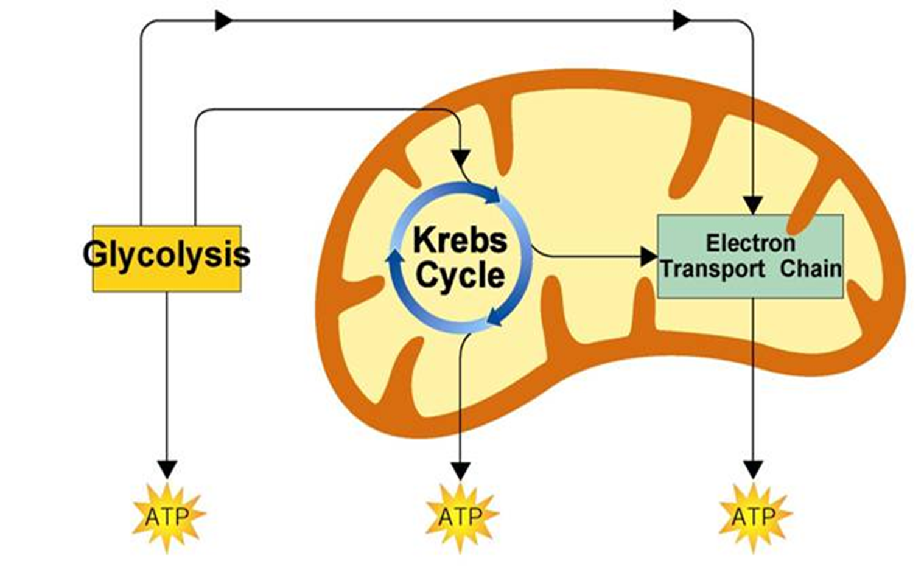

Products=

Reactants=

Summary=

Products=

Reactants=

Summary=

Products=

Reactants=

Summary=

**AEROBIC Respiration= NEEDS Oxygen**