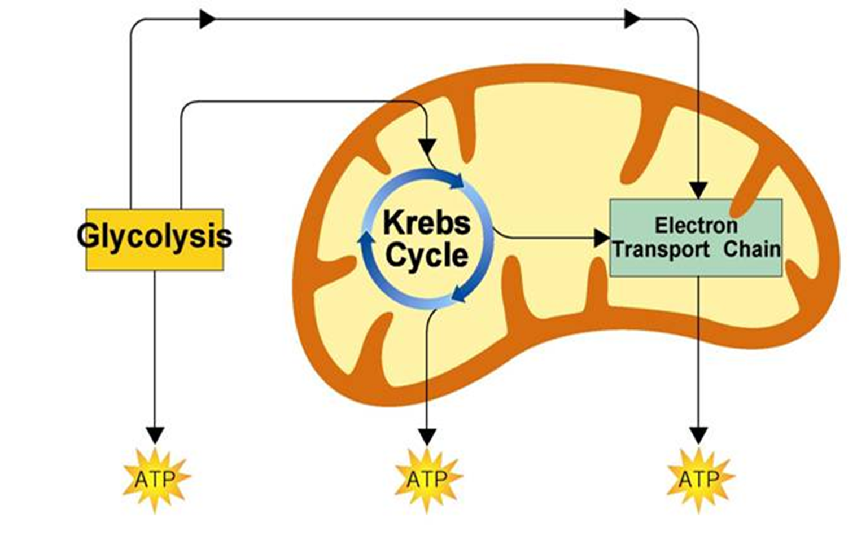

***ANA*EROBIC Respiration= Does NOT need Oxygen**

Products=

Reactants=

Summary=