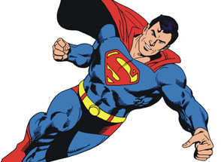
Fictional Character Project
OBJECTIVES: Students will use superhero traits and genetic crosses to better understand genotypes, phenotypes, Punnett squares, the Principle of Dominance, homozygous vs. heterozygous, and the possible outcomes of genetic crosses.
PROCEDURE:
1) Use the Internet to locate fictional character (Marvel/DC Superheros, Disney characters, Harry Potter characters, TV characters, famous people) sites that give backgrounds and physical characteristics of the fictional characters you choose. (Examples: Wolverine, Superman, The Hulk, etc.).
2) You must search for a male and female fictional character and develop a list of physical traits and/or powers that these fictional characters have in common and that can be identified by physically looking at the characters (ex: Eye color) and also those unique to that individual (ex: Superman flight). Develop a list of 10 minimum physical traits (phenotype) that your character has and determine the dominant and recessive alleles for each trait.
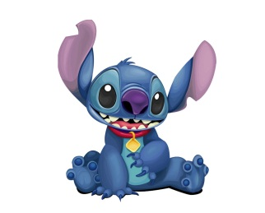
3) Create a genotype for each characteristic of each fictional character and then put the genotype and phenotype in a Family Genotype & Phenotype Chart. See example below Procedure. Be sure to include an even mix of Homozygous Dominant (AA), Homozygous recessive (aa), and Heterozygous (Aa) genotypes for the parents – your offspring will be very boring if you don’t!
4) Draw Punnett squares to show the crosses for each trait and the possible genotypes of the offspring that will result from this cross.
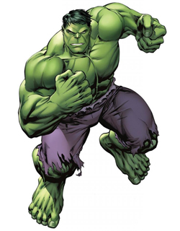
5) For each trait, your character offspring will have the trait that the majority of the boxes in the Punnett Square have (ex: 75% AA & Aa for blue hair, 25% aa for red hair Offspring will have blue hair). If the two possible phenotypes are tied (50% and 50%), then you can choose which trait you would like the offspring to have (but only if it is 50-50!). On your poster, highlight/box/star the “winning” genotypes in the Punnett Squares you created.
6) You will then draw the new fictional character baby based upon the set of traits it has according to your Punnett Squares. This picture must be drawn by hand! You will also make up a new name for your fictional character offspring.
7) Create a poster that shows the complete work of creating this new fictional character. Your poster must include:
- Pictures/drawings and names of the parent fictional character
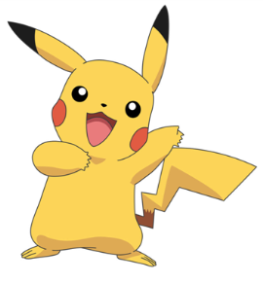
- Family Genotype & Phenotype Chart with a minimum of 10 physical traits identified
- Which alleles are dominant vs. recessive for each trait
- ALL Punnett Squares set up and completed neatly
- Identification on the Punnett Square as to which trait is the one we will see in the offspring
- Drawing of the new fictional character offspring (needs color!)
8) Students’ fictional character posters will be put on display for the class to evaluate.

CREATING A Fictional Character FAMILY
Superhero Trait Chart—Example
1)Hair | H - red hair | h - blonde hair
2) Eye color | B- Blue | b- Green
3) Super human strength | S- Strength | s- Normal Strength

Family Genotype/Phenotype Chart -- Example
 | Mr. Incredible Genotype | Mr. Incredible Phenotype | Elastigirl Genotype | Elastigirl Phenotype
Hair | Hh | Blonde | hh | Red
Eye Color | BB | Blue | bb | Green
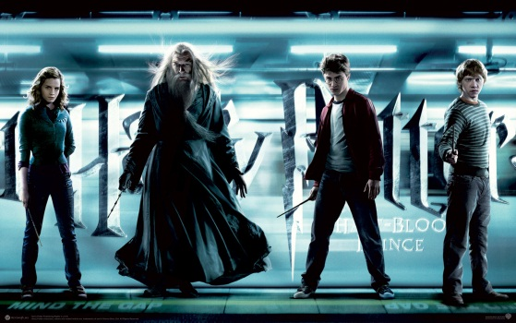

Fictional Character Project Poster – Scoring Guide
 | 10 points | 7 points | 5 points | 2 point
# of Traits identified | Identified 10 or more traits | Identified 7 – 9 traits | Identified 5 – 7 traits | Identified less than 5 traits
Creation of Superhero Parents | Male and Female character chosen  The dominant and recessive traits have been identified in the trait chart  A genotype is created for each characters characteristic and listed in correct chart | Male and Female character chosen  The dominant and recessive traits have been identified | Male and Female character chosen | Incorrect gender for character is chosen
Determining the traits of the offspring | Genotypes and phenotypes for all traits are correct | 1-2 genotypes or phenotypes are incorrect | 3 genotypes or phenotypes are incorrect | More than 4 genotypes or phenotypes are incorrect
Creation of Punnett Squares | Created the correct amount of Punnett squares  Each square shows all possible outcomes  All crosses are done correctly | 1-2 Punnett squares have mistakes | 3 Punnett squares have mistakes  Missing no more than 1 Punnett square | More than 4 Punnett squares are incorrect  Missing 2 or more squares
Poster | All elements of poster are easy to find & read  Poster is organized and pleasant to look at | All elements of poster are easy to find & read | Poster has all the elements but is not neatly organized  Hard to find the information | Missing information  Unorganized

Total Score: _________ out of 50 points

