Fishing for Life: Studying the Effect of Human Activity on Our Ecosystem

Background
Overfishing occurs when fish are being caught faster than they can reproduce and replace themselves. Overfishing can affect biological diversity. Biodiversity is the diversity of living things, and can be thought of as occurring on three levels: genetic, species, and ecosystem. According to marine ecologists, unsustainable fishing is the greatest threat to ocean ecosystems. The practice destroys the physical environments of marine life, and distorts the entire food chain in the oceans. If the food chain breaks, the consequences will ripple up and down to all the living organisms that are in the chain

Procedure
- Each group of four “fisherman” will start with 16 fish (4 red skittles, 4 green skittles, 4 orange skittles, and 4 yellow skittles)
- Each fisherman will fish with two straws taped together end to end. Hands cannot be used during fishing!
- Each fish has a ‘current market value”:
Red Skittles = $10.00 Green Skittles= $3.00
Orange Skittles = $5.00 Yellow Skittles= $3.00
- Each fisherman must catch one fish per fishing season in order to stay in business; it is up to each fisherman to decide how many, beyond the required one fish will be fished.
- Each fishing season will last 10 seconds.
- At the end of each season, one fish (of the same species) will be added for each fish remaining in the lake commons.
DATA:
Copy this chart and fill in information:
Fish | Season 1 | Season 2 | Season 3 | Season 4 | Season 5
Red
Green
Orange
Yellow |  |  |  |  |  | Total for Group
Total Fish Harvest
Total Income

Data Analysis: Make a BAR GRAPH of your data for the number of fish caught in each fishing season. Use a different color to represent each fishing season. Make a key to show the colors code for all the different locations. Remember a title & labels.

Season 1
Season 2
Season 3
Season 4
Season 5

SUSTAINABLE fishing is when a fisherman earns a profit, but his methods maintain a healthy ecosystem so generations to come will be able to fish.
QUESTIONS
1. Describe the strategy you used when fishing over 5 seasons?
2. Did your strategy prove to be beneficial? Why or Why not?
3. What would have happened to the fish population if you fished all the fish in one round?

4. What needs to be done to make fishing sustainable?

5. What do you think stops people from following the rules and regulations made to keep fishing sustainable?

6. What laws or regulations would you put into place to ensure sustainable fishing?

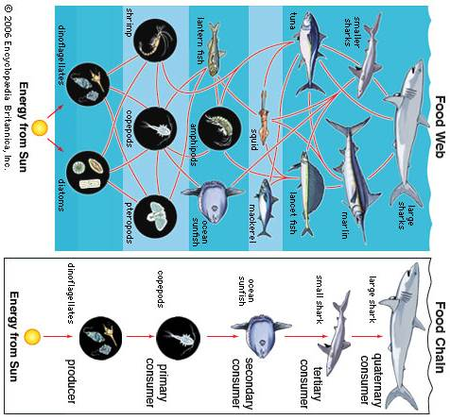

1. Based on the food web, what do you think would happen if the tuna were overfished? What would that do to the population of lower level consumers like squid/mackerel?

2. What kinds of impacts would overfishing of shrimp have on the ecosystem?

3. How does overfishing impact biodiversity??

4. What would be the impact on mackerel if the squid were overfished?

5. How are the shark and dinoflagellates actually dependent on EACHOTHER?

6. Why is it important for ALL countries to develop sustainable fishing techniques? (there are ecosystem and human considerations)
7. In this ocean ecosystem, which organism could be considered a keystone species? Why?

Please read this article AFTER completing the WHOLE activity

