Main Ideas Evolution Animal Behaviors
- What do we mean when we say inherited?
  - Whom are traits inherited from?
  - How are they passed down?
Inherited vs. Learned
  - Give some examples of things you inherit:
    - Looks…____________________________________________________
    - Behaviors… ________________________________________________
What are some things you are NOT born knowing?
Learned Behaviors
  - List some traits animals must learn and share with a partner to see if you come up with some similar or different ideas.

Discuss the following pictures and label them on your paper as learned or instinct. Some may be both, be able to explain.
Animal Behaviors:
Learned vs. Instinct:
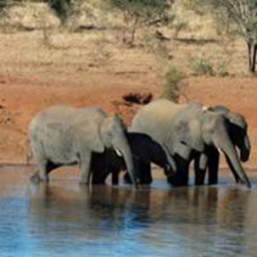
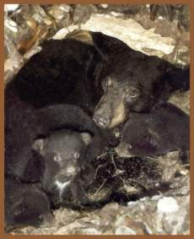
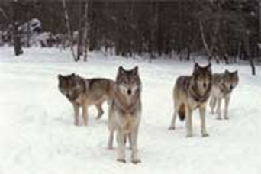

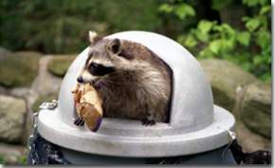
Be able to share your thoughts on how or why you labeled them.

How would you explain the last three pictures on this page? Instinctive or Learned behaviors?
A Few More Behaviors to Discuss:
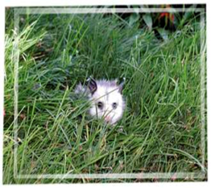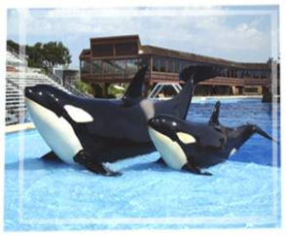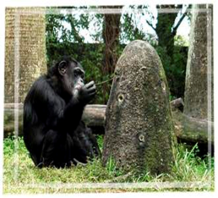

- Why?

Other Instinctual Behaviors:
Fight or Flight response:
  - When ___________________ the animals _________ behavior will be triggered.
  - Those behaviors can be to ___, ____, or _______________________.
Main Ideas Evolution Animal Behaviors
Some Other Behaviors:
- Living in herds and packs vs. living solitary lives
- Three reasons to live in herds or packs:
1. ______________________
2. ______________________________________
3. ________________________________________________
Solitary Lives:
Why do some animals live solitary lives?
Some animals live alone because______________________________________
________________________________________________________________
Most prey animals live in social groups, packs, schools (fish), herds, ___________
Predator vs. Prey:
__________________________________________________________________
Some do live solitary lives. ______ these animals live determines ____ they live…can you look at the pictures below and conclude why?
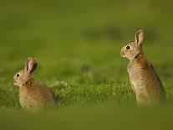
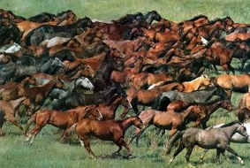
Some prey animals react to a predator very differently from other prey animals.
Horses: Rabbits:
Run away from predators. Freeze in the presence of a predator,
and will try to hide as soon as possible.
Predator animals can ________________________________________________.
Predator vs. Prey continued:
They live in packs not for protection like prey animals, but for _________________
____________________________________________________________________.
Some predator animals do live in social or family groups as well (such as chimpanzees and apes).
Female animals: tend to __________________________ lead the herd/pack and be the hunters/gatherers of the pack/herd and watch/listen for danger.
Behavioral Differences Between Male And Female Animals?
Male animals: In some cases ________________________________________________
____________________________ and thus the passing on of his traits. The stronger male wins, which means the stronger traits get passed on. There are Alpha males and females in all packs/herds. What is the difference between them and non-alpha animals?

