Main Ideas Speciation
Sources of Genetic The ____ main sources of genetic variation in a population are _________ and _____________
Variety Sexual reproductions ____________________ through meiosis
Mutations create _________________ that sometimes makes an organism more fit for its environment
Ex: A mutation that gave brown bears _________________________________________
______________________
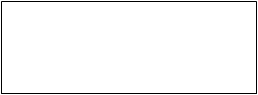
Original DNA
Mutated DNA
Original Phenotype
Mutated Phenotype
Mutations=Variety

Lethal Alleles How are lethal alleles maintained in a population? Shouldn’t natural selection remove these?
Alleles that are lethal in a ___________ individual may be carried in a ____________ individual
For Example: if two parents are carriers of a bad allele and an individual inherits both bad alleles, they will get the lethal disease.

Gene Pool Consists of ___ genes, including all the different alleles that are present in a population
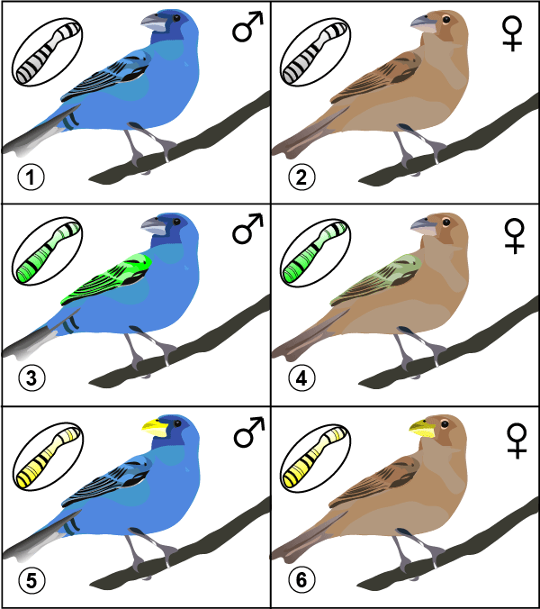

Allele Frequency _______________________________________________
Ex: How many in this class have at least one dominant allele for brown eyes
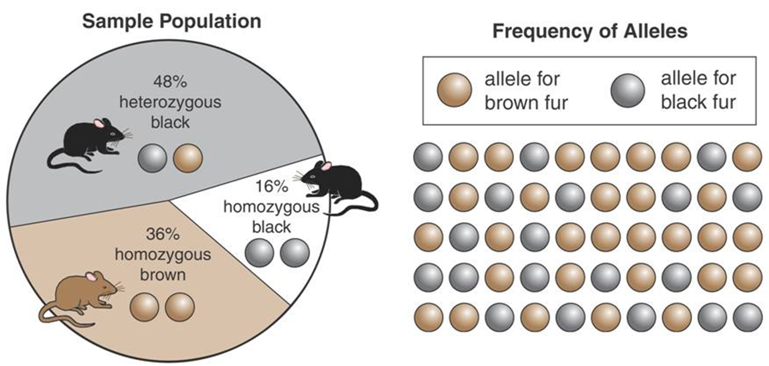
Sexual reproduction produces different phenotypes, but it does not change the relative frequency of alleles in a population

Gene Pool for Fur
Color in Mice

How is evolution In genetic terms, evolution in any change in the relative frequency of alleles in a population
defined in genetic
terms?

Main Ideas Speciation

The Equation Hardy- Weinberg equilibrium= population allele frequiencies
P= dominant allele (A) pq= (Aa) heterozygous q= recessive allele (a)
The sum of p+q=1, then solve p2 + 2pq + q2 = 1

What is Speciation Speciation is the formation of a ____
Speciation is caused by ______________________
-Reproductive isolation is when _______________________________________. There are ___ types of reproductive isolation.

Reproductive #1. __________________ is when genetically similar populations are able to breed but don’t Isolation due to different behaviors.

#2. ___________________ is when two members of a population are ________________ such as mountains, canyons, bodies of water, etc.
-Ex: Squirrels on opposite sides of the Grand Canyon

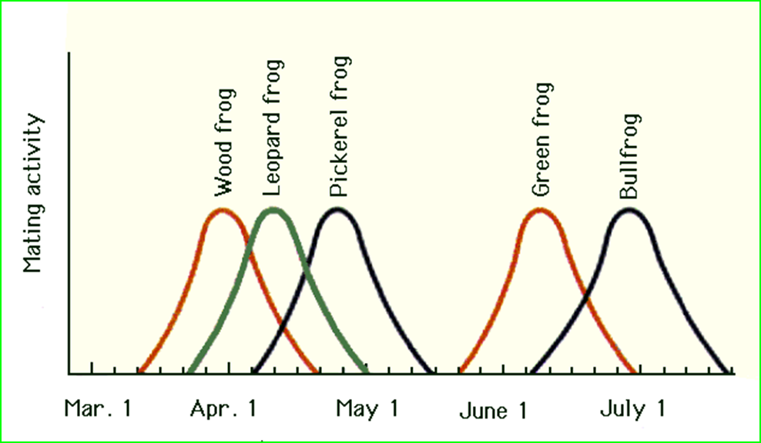
#3. ____________________ is when members of a population ________________________ of the year.
-Ex:

Main Ideas Speciation

Genetic Drift A _____________________________ (can be caused by fire, flood, etc.)
-in __________________, individuals that carry a particular allele may leave more descendants that other individuals do, just by chance.

Founder Effect When allele frequencies change as the result of ______________________________________
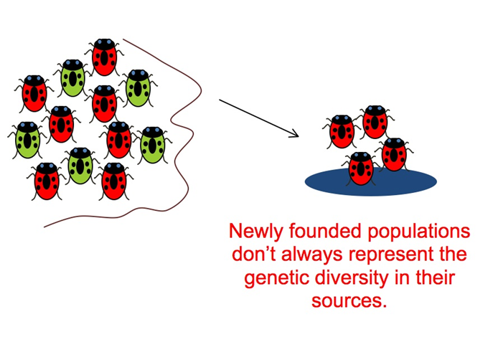

Stabilizing Favors the formation of ____________________________
Selection

Disruptive Favors ______________________________________
Selection

Directional Favors the formation of a ___________________________
Selection

SUMMARY

