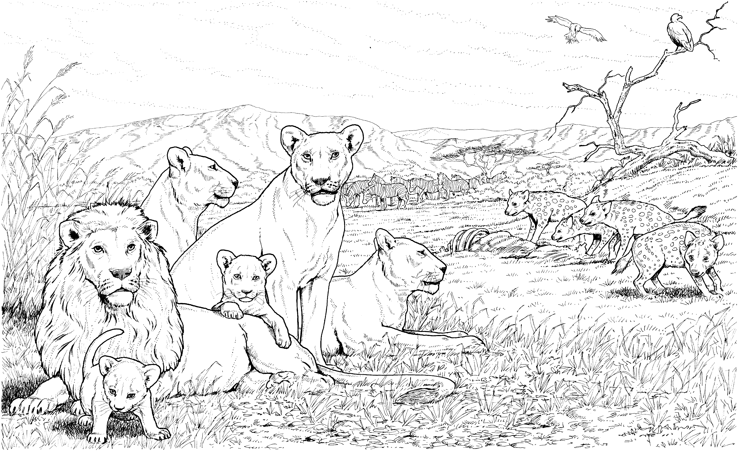
Sorting Activity: Limiting Factors of Population Growth

Directions:
Step 1. Cut out each piece in the table below.
Step 2. You will create a two-column table in your notebook for the two types of limiting factors of population growth.
Step 3. Match the correct definition of the limiting factor and place it under that column.
Step 4. Sort the remaining pieces containing events/scenarios into the correct column for the type of limiting factor they are, either Density-Independent or Density-Dependent.
Step 5. Get your sorting checked by a teacher before you paste the pieces into your Science Notebook.

A tornado passes through a patch of wilderness and destroys all the plants in its path. | The people of a city are constructing a dam in the local, natural river to produce and store energy.
A pride of lions is on the hunt for zebra and antelope more frequently because their pride produced more offspring this year. | Lyme disease is being spread by ticks that jump from organism to organism.
Due to a drought this year, the desert ecosystem will experience decreased water availability and extreme heat. | Any factor in the environment that does not depend on the number of members in a population
Wolves in Canada are having to aggressively compete with each other in order to hunt the limited number of deer. | A population of meerkats is experiencing rapid transmission of fleas, that are attaching to them and feeding on their blood, because they live in close quarters in their social groups.
Any factor in the environment that depends on the number of members in a population | A town’s mayor has a species of trout not native to the area transported into the local lake, that has its own species of trout, tin order o increase sales for fishing.
Density-Independent Limiting Factor | Density-Dependent Limiting Factor

