Main Ideas Ecology
What is Ecology Ecology is__________________________________________________________
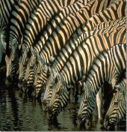
Levels of Individual/Species____________________________________________
Organization ____________ is a group of the same organisms living in the same place
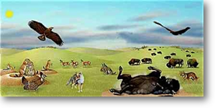
____________ is all the different populations living in the same area
An ecosystem is______________________________________________________
Biomes are__________________________________________________________
The biosphere is_____________________________________________________

Ecosystem Biotic factors are all the ________ things in an environment
Components ________ factors are all the non-living things in an environment

Energy Transfer The ____ is the source of all Earth’s energy
________________are organisms that use _________ to make their own _______
Heterotrophs/consumers are organisms that must _________________________________ to get
food/energy.
5 Types of consumers:
_______ eat plants only.

_______ eat meat/flesh only

Omnivores eat both ___________________________

__________ eat dead/organic remains of other organisms (no mouth)

__________ eat dead/organic remains of other organisms (with a mouth)

