Main Ideas Ecology
Energy Flow Energy flows _________ an ecosystem in _______ direction (can be used up, NOT recycled)
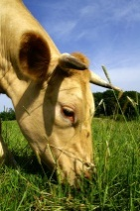
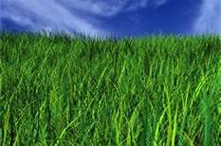
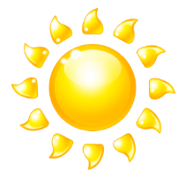
In an ecosystem Sun autotroph heterotroph

Food Chains Food chains show how energy _______________________________________________________
Each level in the food chain is called a _________________. Land (terrestrial) ecosystems usually
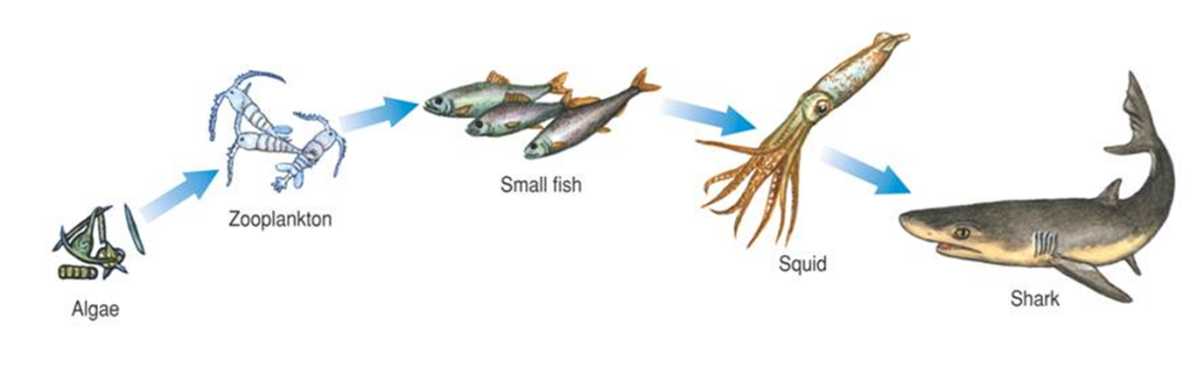
have ____________________.

PRACTICE: Put (draw) the organisms on the board into a food chain in the box below:

Food Web A food web links all the ______________________ in an ecosystem together.
PRACTICE: List(you don’t need to draw) List ALL the food chains in the food web on the board

