Main Ideas Community Ecology and Resources
Ecosystem An ___________ includes all the biotic (living) and abiotic (non-living)factors in an environment
Resources ________________ can be regrown or replaced when they’re used. EX:________________
Non-renewable resources either can’t be replaced when used or it __________________
EX: __________________

Biodiversity Biodiversity is the sum total of different organisms on Earth or in a specific area. Biodiversity is
critical to our survival because it provides___________________________________________.
Which area has Area 1: zebras, elephants, grass, trees, lions, hyenas, giraffes, gazelles, cheetahs, hippos, rhinos.
more biodiversity Area 2: trees, grass, lions, elephants, deer, antelope, cheetahs, crocodiles, giraffes

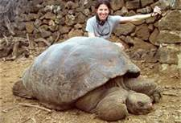
Threats To _________________ is when the last member of a species dies.
Biodiversity
“Lonesome” George Died June 24, 2012. He was the last tortoise of the Chelonoidis abingdonii species, and he was approximately 150 years old

A species close to extinction is _________________.
Introducing ___-___________ species. Humans regularly move plants/animals to new places where
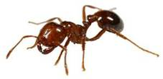
they grow, reproduce beyond control, using resources in the area, causing native plants/animals to
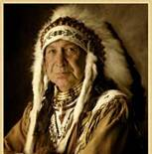
die off.

