Main Ideas Biochemistry-Macromolecules
Carbon Bonding ____________________ are made mostly of carbon C atom. Most matter in living
organisms is made of organic compounds.
QUESTION: How do carbon’s bonding properties contribute to the existence of a wide
variety of biological molecules?
Answer: ________________________________________________________________
_______________________________________________________________________
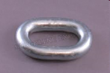
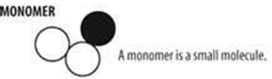
_______________________________________________________________________
Macromolecules A _____________ is a small, single molecule.
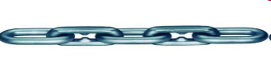
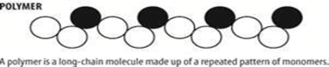
A _____________ is a molecule made of monomers linked together in a long chain
_______________ are large polymers, sometimes thousands of molecules long.
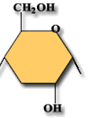
4 Types of CARBOHYDRATES
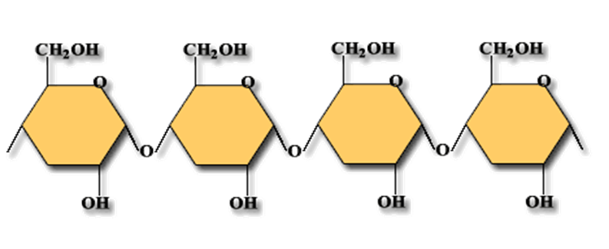
monomer=____________________________

Polymer= _____________________________

Macromolecules FUNCTIONS- 1.) ___________________________________________________________________________
2.)____________________________________________________________________________

PROTEINS
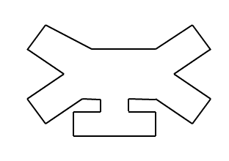
monomer=________________ Polymer=______________
The _________ and __________ of amino acids determines the type of protein.

FUNCTIONS- 1.)____________________________________________________________________
2.)____________________________________________________________________
3.)____________________________________________________________________
Main Ideas Biochemistry-Macromolecules
NUCLEIC ACIDS
Monomer= a 3 unit piece called a ___________
Polymer= (2 types) __________ OR __________
FUNCTIONS-1.) __________________________
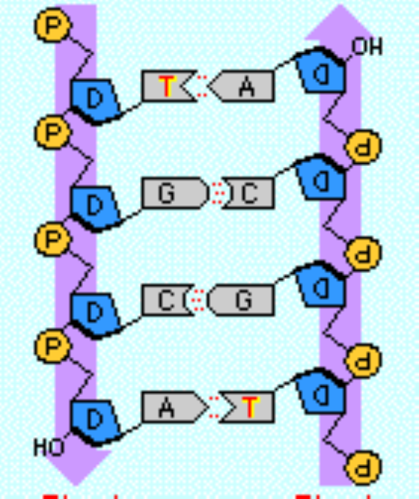
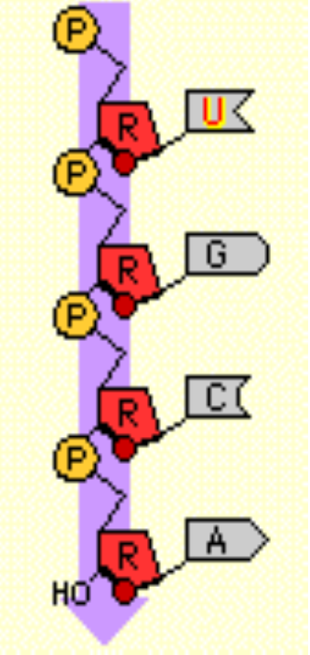
_______________________________________
_______________________________________
Note= A gene is a SECTION of DNA that controls
The making of a single trait.

LIPIDS
Phospholipids (like those that make your cell membranes) generally don’t dissolve in water. They have NO true monomer or polymer. Instead, they have a glycerol head, and 2 or 3 fatty acid tails. They’re the main structural component of cell membranes.
Monomer= no true monomer
FUNCTION= 1.) _________________________________________________
2.) _________________________________________________
EX: fats, oils, waxes, phospholipids, steroids
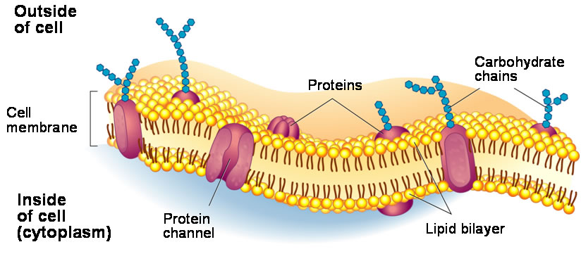

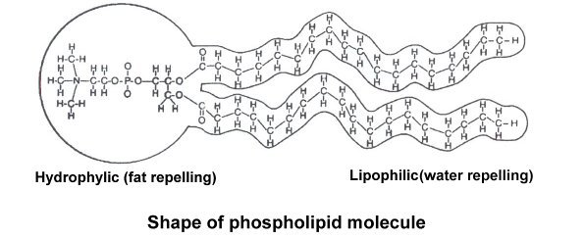

Summary- Write a 6-8sentence paragraph summary on macromolecules. Be ready to present.

Main Ideas Biochemistry- Chemical Reactions
Enzymes and A chemical reaction is a process that changes one set of chemicals into another by ___________
Chemical Reactions ________________________.
______________ are a type of ____________ that act as a biological catalyst by _____________
chemical reactions in cells. Enzymes speed up reactions by lowering the ________________
_______________ of the reaction.
Activation Energy Most chemical reactions _____________________________________________________________
The energy needed to start a reaction is called ___________________________________________.
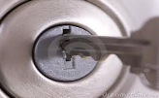
How is Activation Enzymes only work w/SPECIFIC reactants called _____________. The enzyme and its substrate work
Energy Lowered? like a _____________________
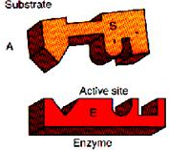
The ________________ is where enzymes/substrates fit together.
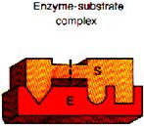
When the substrate attaches to the activation site, the enzyme slightly ___________________
____________________, which weakens the bonds of the substrate, lowering
activation energy.
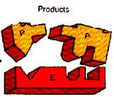
_______________________ are attached until the reaction ends.
Substrates are change into new/different substances
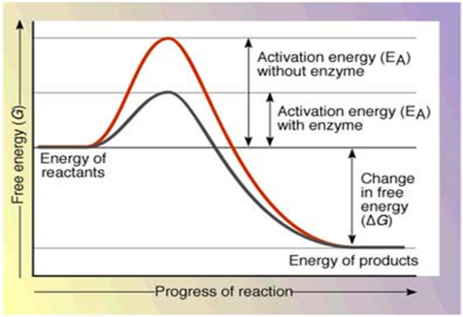
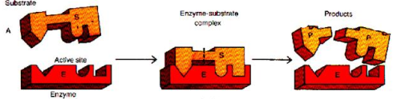
______________ are unchanged and can be used _________________

Conditions for Most enzymes require specific conditions:
Enzyme Activity 1.) ______
2.) Temperature _____________
If temps or Ph are too high/too low the ______________________________________________
and no longer fit with substrate.

