Main Ideas Protein Synthesis
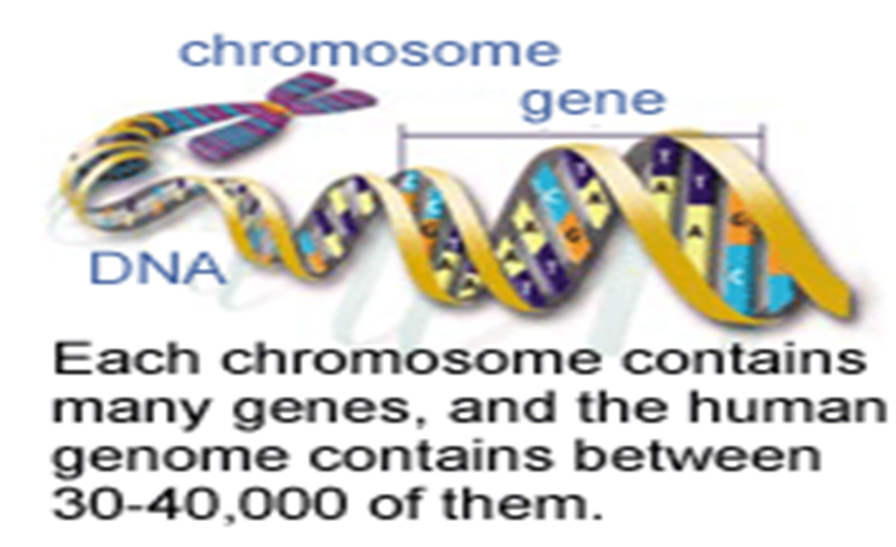
Gene ____________ of DNA that controls/codes for a __________________

3 Types of RNA 1) _________________) –carries _______ making _________ from DNA.

2) ________________ - part of ________- ______ ______

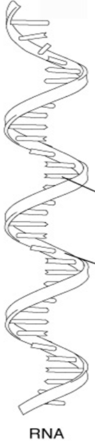
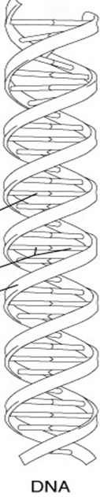
3) ____________ - _____________ __________ (building blocks of proteins) to ribosomes to make a protein
DNA vs. RNA -DNA -RNA
-Sugar (__________) -Sugar (________)
-Phosphate Group -Phosphate
-Nitrogen Bases -Nitrogen bases
-A -A
-T =_________ -U =______
1 -G -G
-C -C
-_________________ -_________________

Main Ideas Protein Synthesis
Protein Synthesis
Overview 2 main processes:
1) Transcription- _________ copied __ (in nucleus)
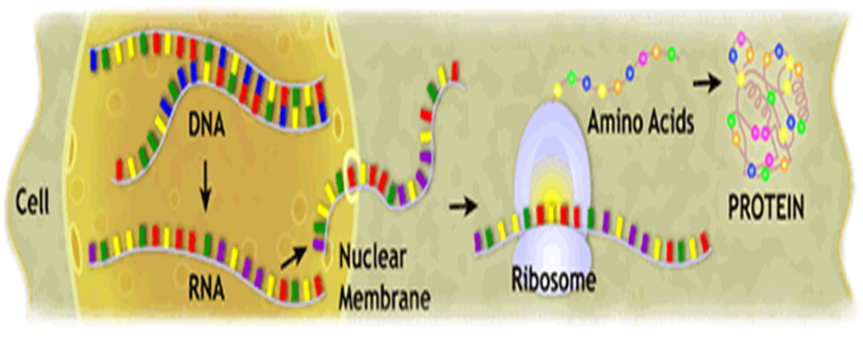
2) Translation- _______ made ______________ (in cytoplasm)

DNA to RNA
Transcription
1) DNA unzipped by__________________________ at a gene begins copying
2) ____ strand of DNA template is _________________
(copied) into _______ using _____________ bases.
3) RNA polymerase reaches___________________________, stops copying

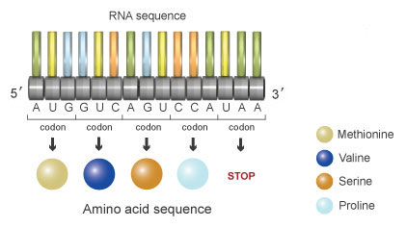
Codon __ consecutive ________________ on _______ that specify __ particular amino acid

Main Ideas Protein Synthesis (continued)

Flow of Genetic Info DNA RNA Protein
(Central Dogma)

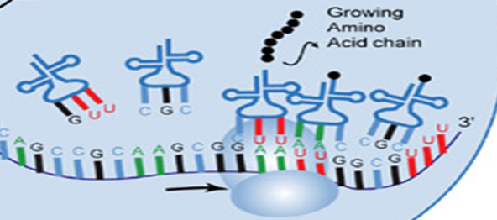
Transcription Translation
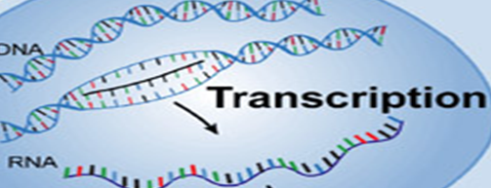

Translation Decode mRNA to Proteins
Steps:
- _____ strand broken into codons
- ___________ reads codons and ___________ them into amino acids
- ________ calls for _______ to bring correct amino acids
- ______ ________ match up with ______ ________
- Amino acids are __________________________ until a _______ codon is reached
- ________________- ribosome complex falls apart. __________________
____________________

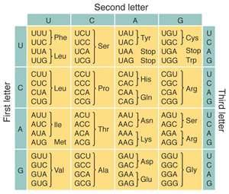
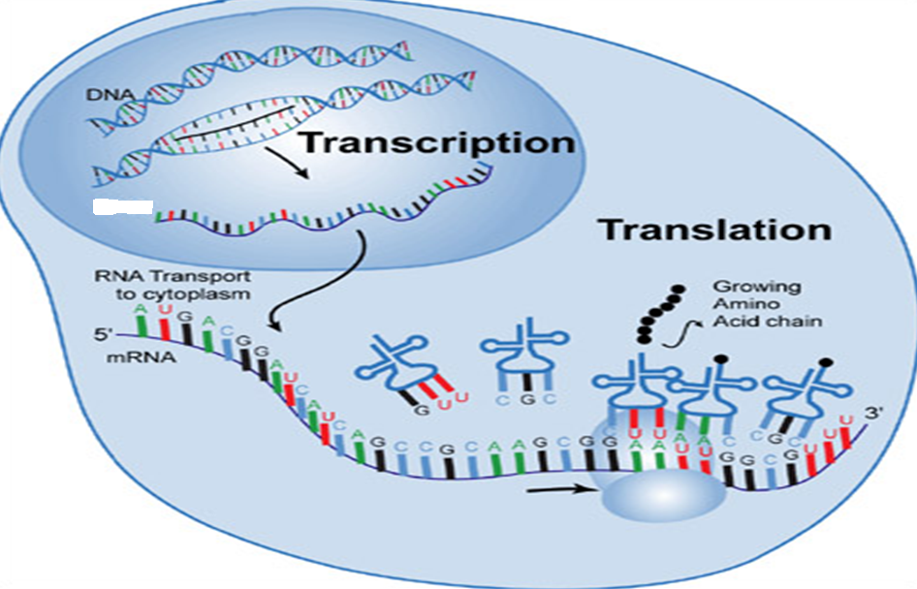
On the picture above, label ALL of the following for FULL credit:
- mRNA,
- rRNA,
- tRNA,
- codon,
- anti-codon,
- amino acid,
- nucleus

Using the genetic code chart to the right complete the following:
- Transcribe (from DNA to RNA) the following DNA sequence. Then, Translate it to an amino acid chain.
DNA-ATCGCCATA
mRNA-
Amino Acids-
- Transcribe AND translate the following DNA sequence:
DNA- ATCGCCATAGCG
mRNA-
Amino Acids-
- Transcribe and translate the following DNA sequence:
DNA-ATCGCCATAGCGCGA
mRNA-
Amino Acids-

