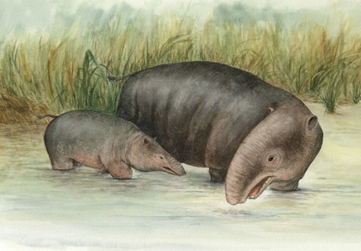
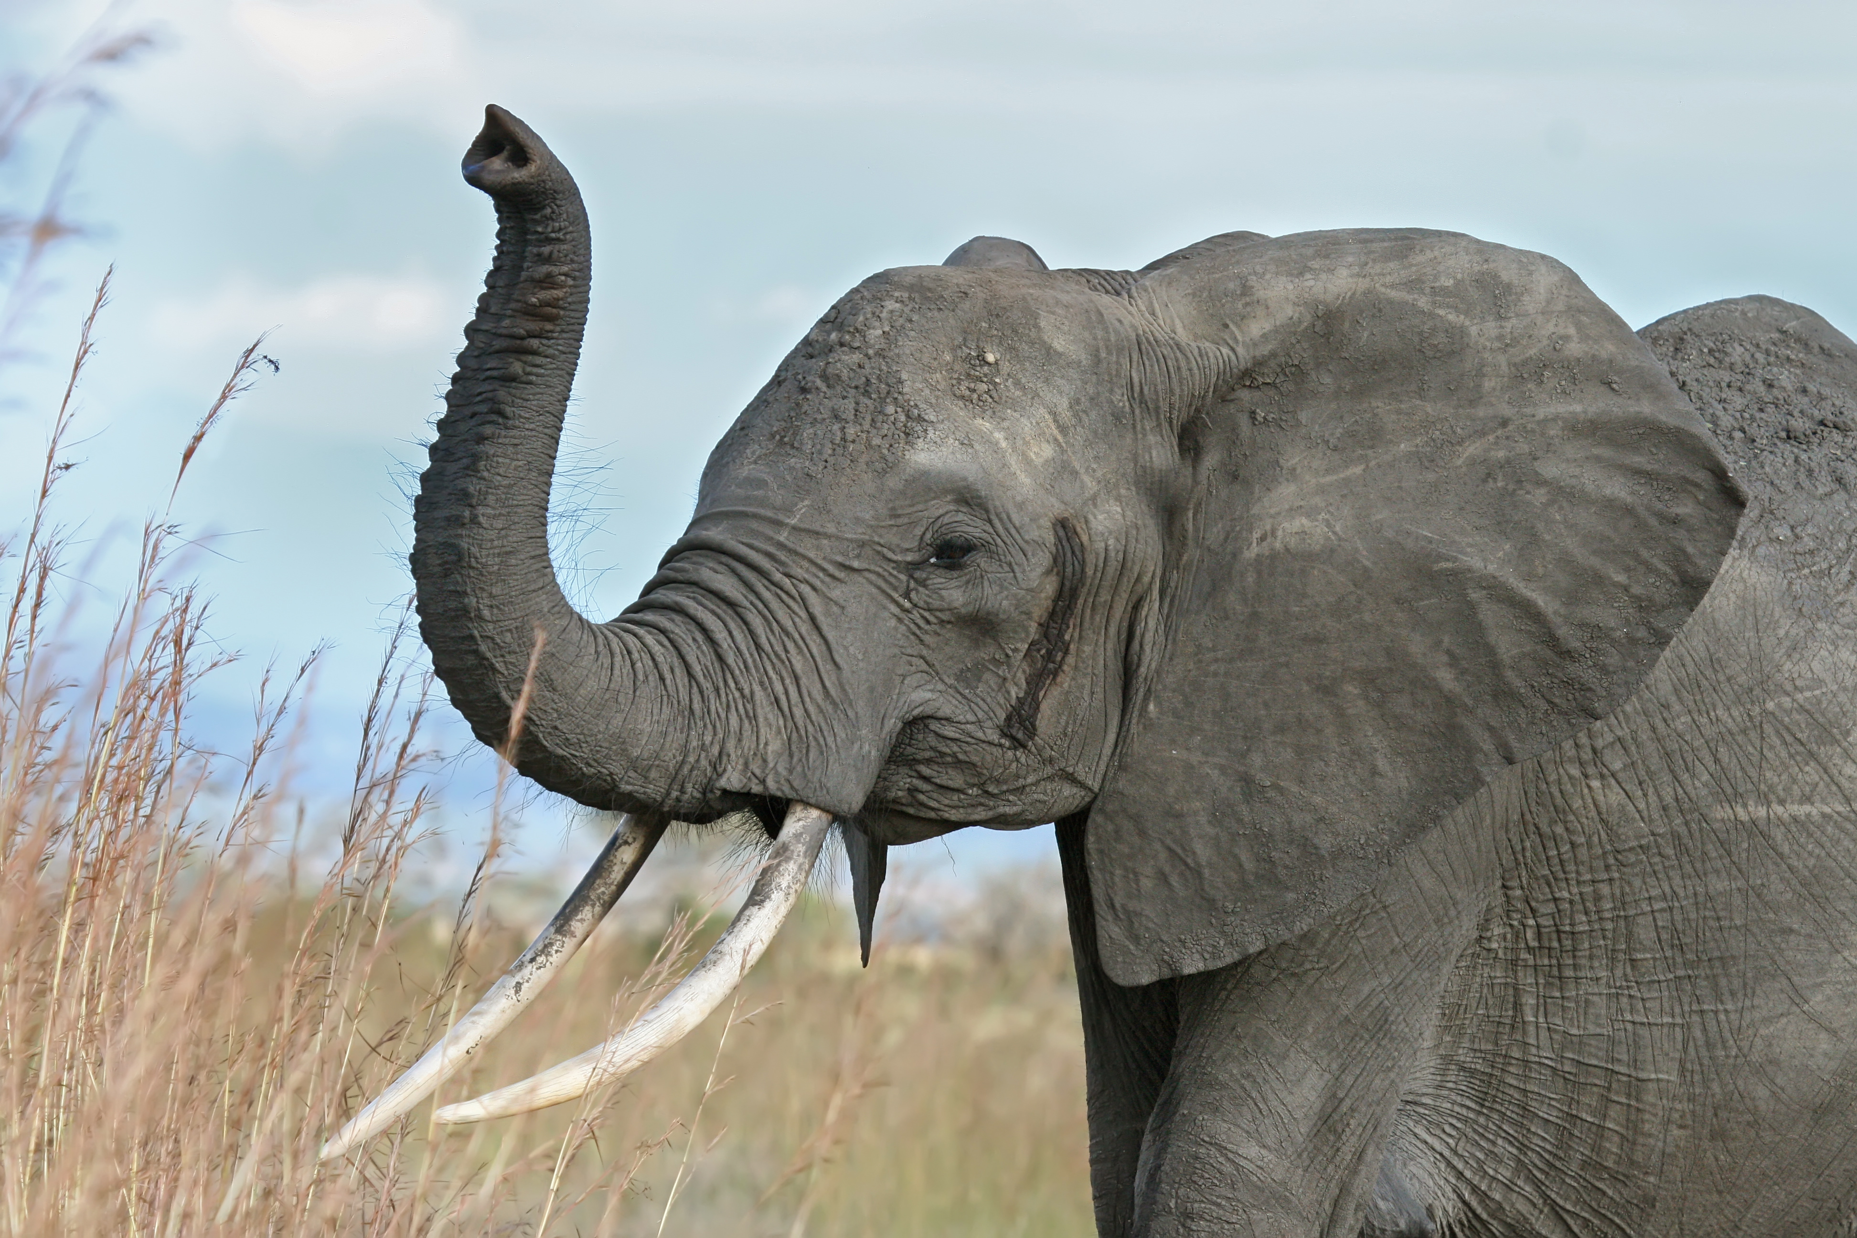
How can a species change over time?
CLASS SET
Theory 1
Theory 2
Theory 1 is known as the Theory of Inheritance of Acquired Characteristics, first presented in 1801. If an organism changes during its life in order to adapt to its environment, those changes are passed on to its offspring. This theory says that that change in a species is made by what the organisms of that species want or need. For example, according to this theory, elephants all used to have short trunks; they stretched their trunks to reach the water and branches. This stretching gave them longer trunks that caused their offspring to inherit long trunks. This theory also says that body parts that are not being used, such as the human appendix and little toes are gradually disappearing. Eventually, people will be born without these parts. This theory also says that things are changing to be perfect, and that there is a predetermined plan and that the results have already been decided.
Theory 2 states that the desires of animals have nothing to do with how or why they change. According to this theory, changes in an organism during its life do not affect the change of the entire species. This theory states that organisms, even of the same species, are all different and that those which happen to have variations that help them to survive in their environments, survive and have more offspring. The offspring are born with their parents’ helpful traits, and as they reproduce, individuals with that trait make up more of the population. Other individuals, that are not so well adapted, die off. Let’s look at the elephant example. Most elephants used to have short trunks, but some individuals naturally had longer trunks than others. When their environment changed, and there was no food or water that they could reach with their short trunks, the ones with short trunks died off (starved to death or died of thirst), and the ones with long trunks survived and reproduced passing on their long trunk trait. Eventually, all of the elephants had long trunks. This theory also states that change does not happen according to any sort of plan.

